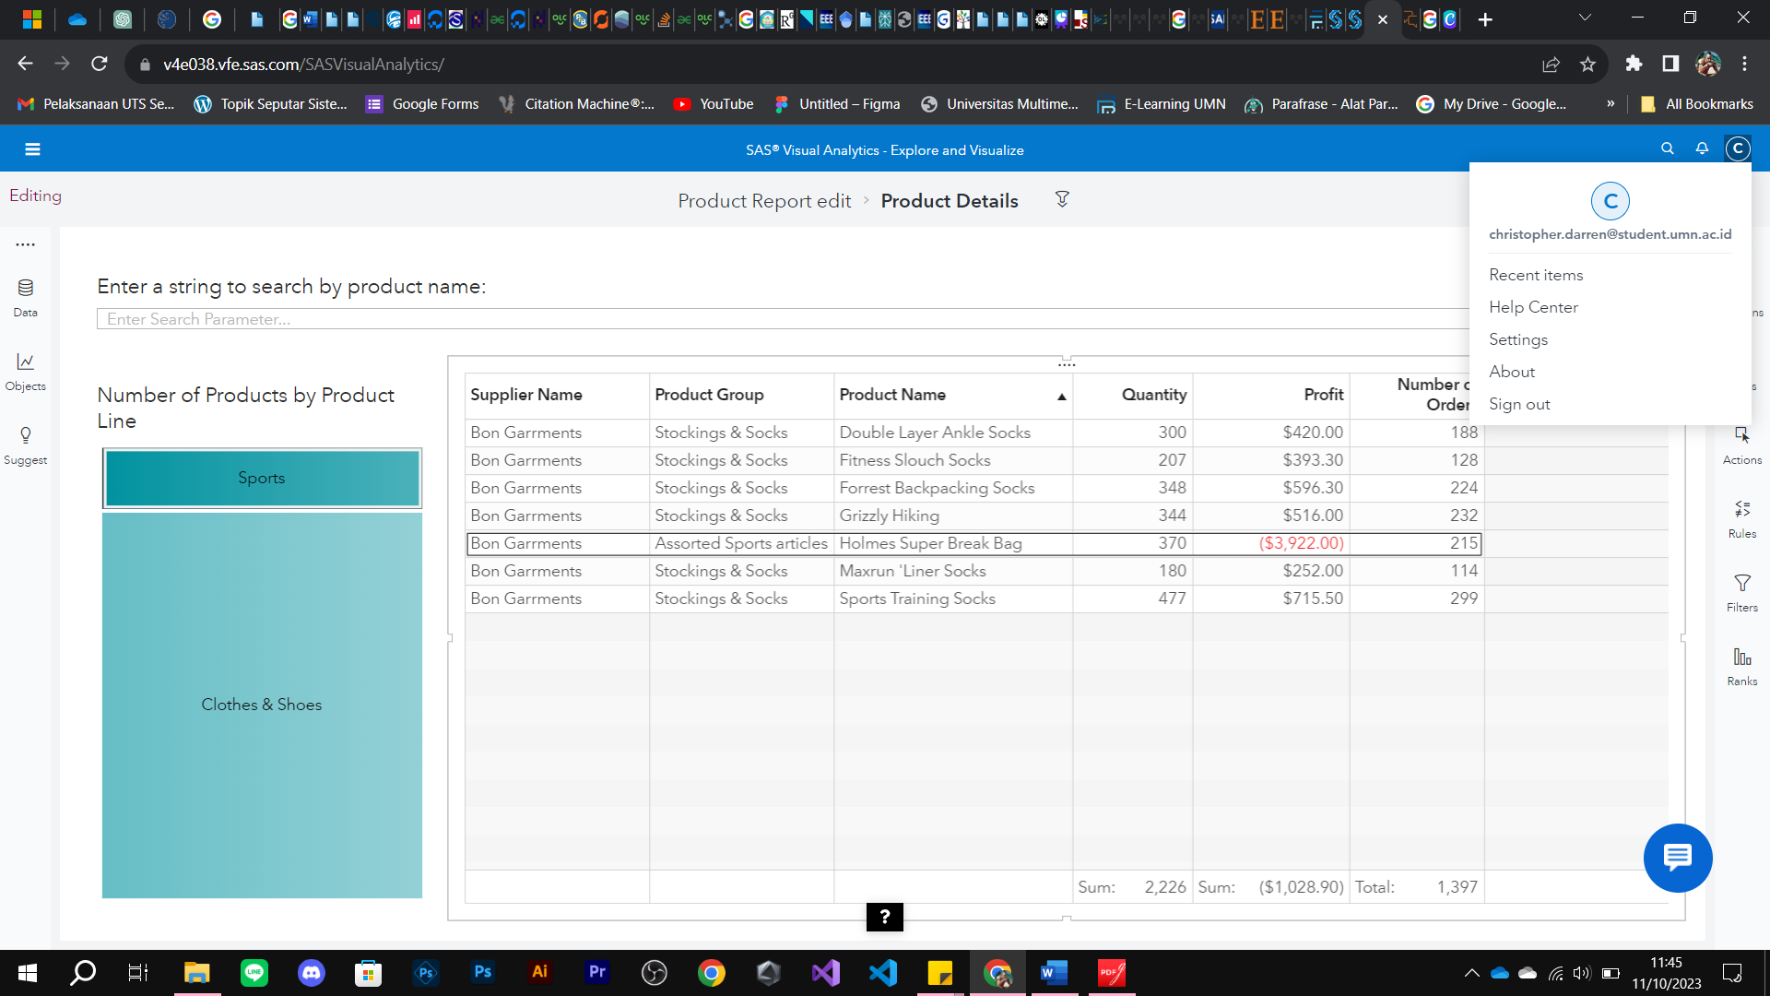

Figure A

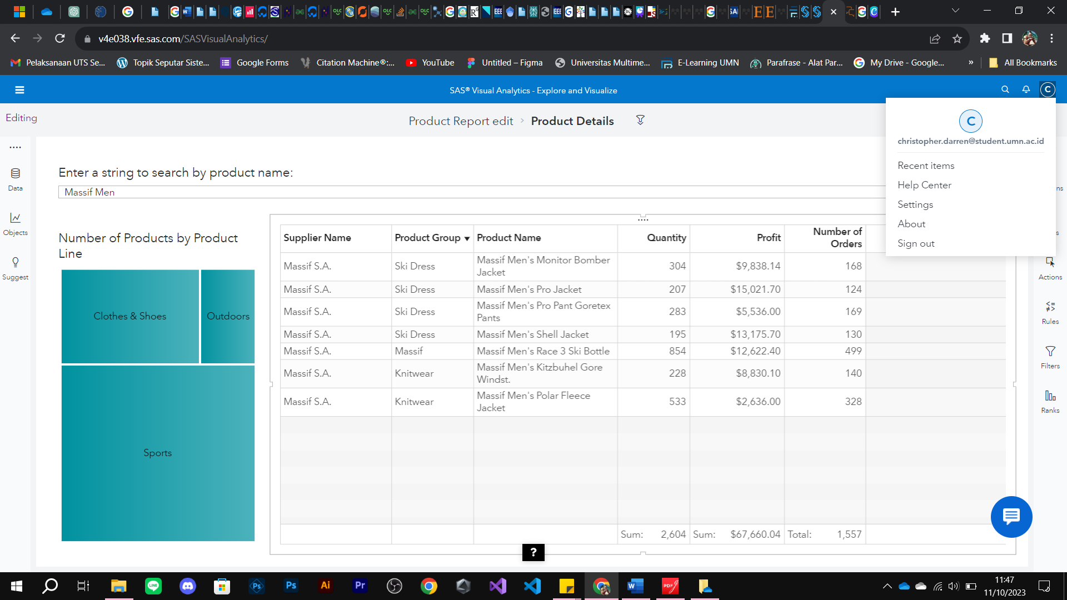

Figure B

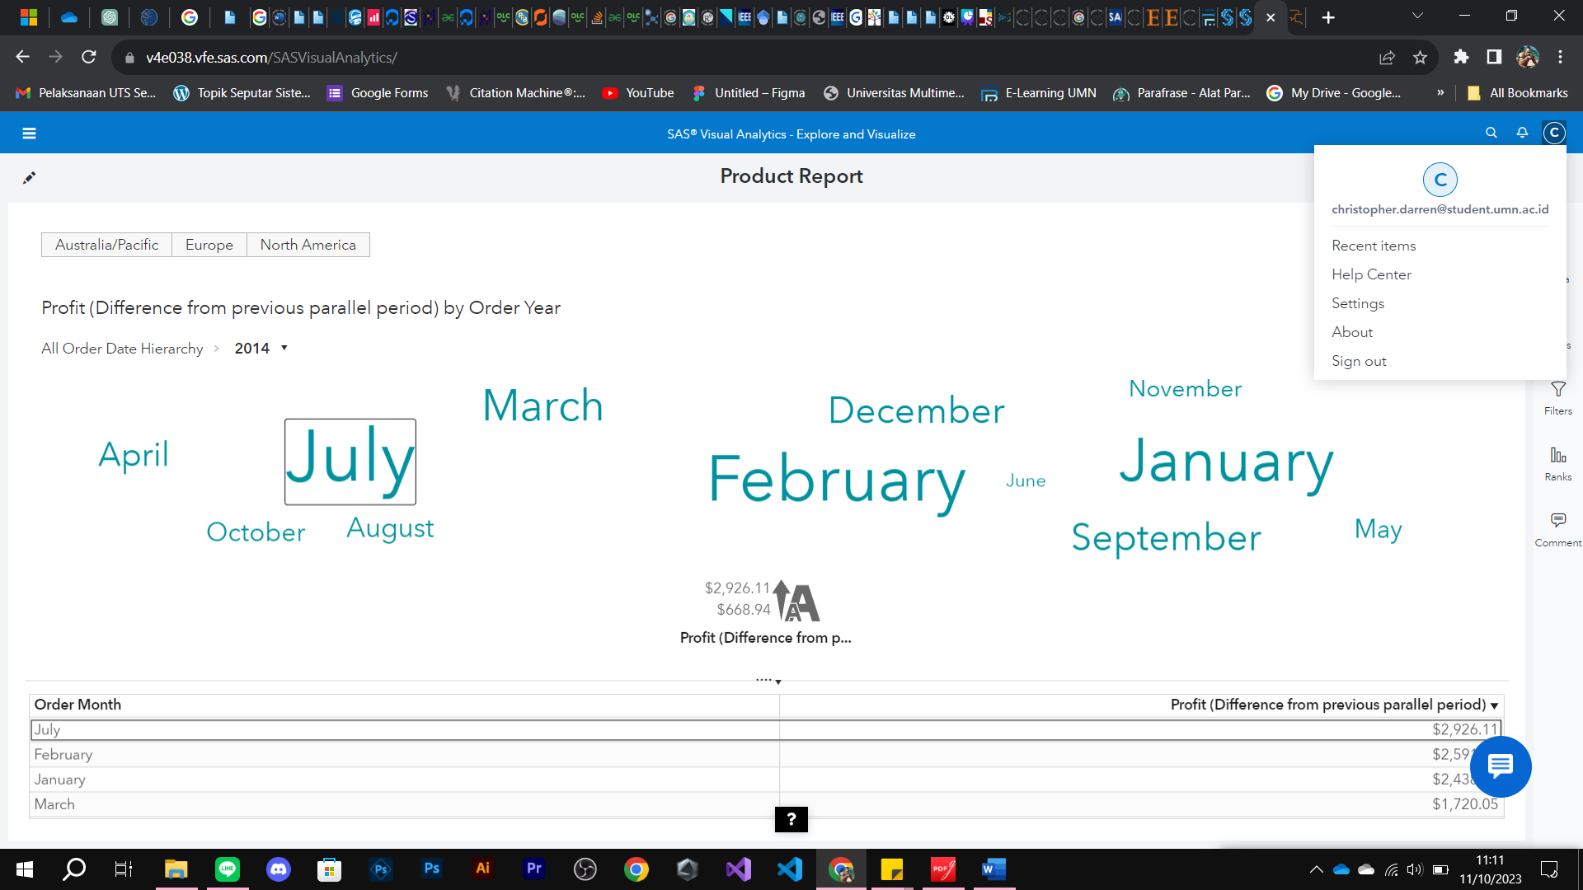

Figure C

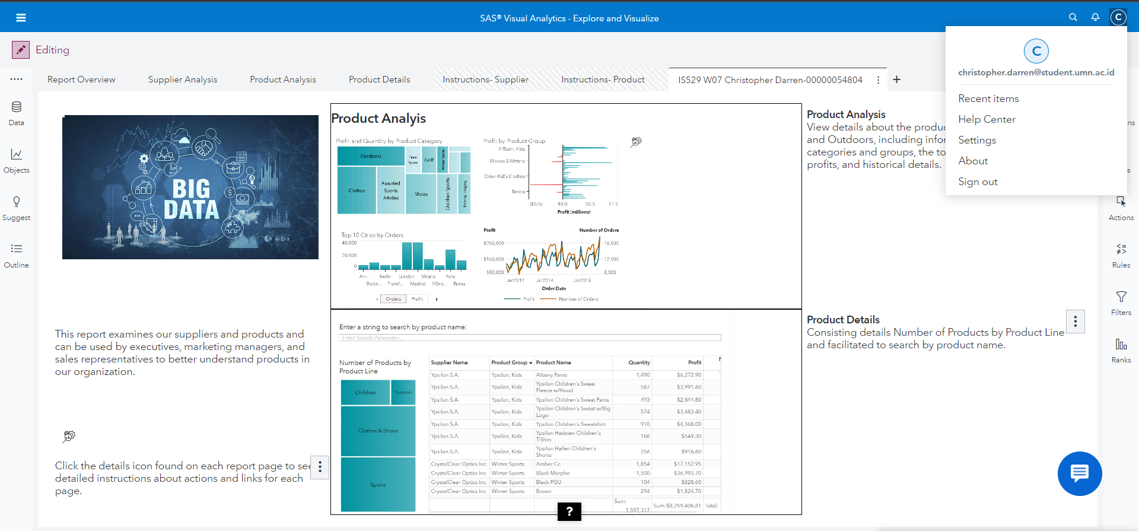

Figure D

Link kerja

<https://v4e038.vfe.sas.com/links/resources/report?uri=%2Freports%2Freports%2Fc17d90a2-dfb8-48d5-9cae-59d32999056c&page=vi3433>